Data Cleaning
- Sheet 1/ Data 1 (Customer Dataset)
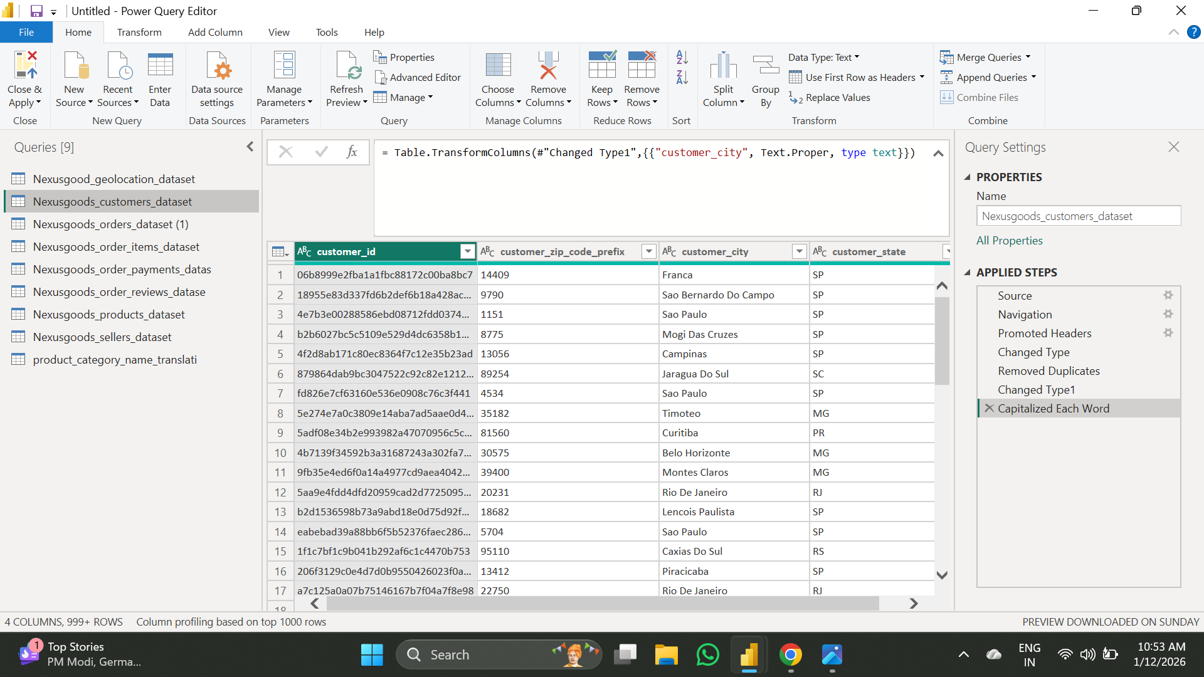

- Remove Duplicates from the column of Customer ID, as it should be unique.
- Change the Zip-Code format as it is required for joining with Geolocation.
- Capitalise each word of City, which helps in grouping and makes it easy to read.
- Sheet 2 / Data 2 (Geolocation Dataset)
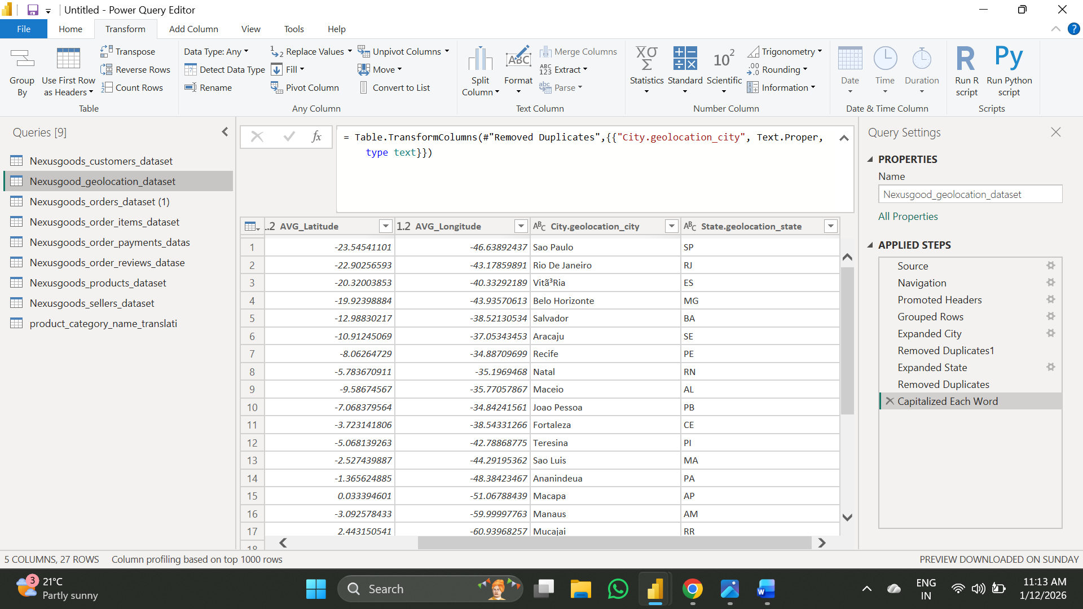

- Grouping by Zip code with geolocation_lat, geolocation_Ing, geolocation_city, geolocation_state.
- After grouping the city and state columns, the column shows “Table”, so I expanded both of them and then just removed the duplicates, as it will be easy to analyse.
- Capitalise each word of City, which helps in grouping and makes it easy to read.
- Sheet 3 / Dataset 3 (Order Dataset)
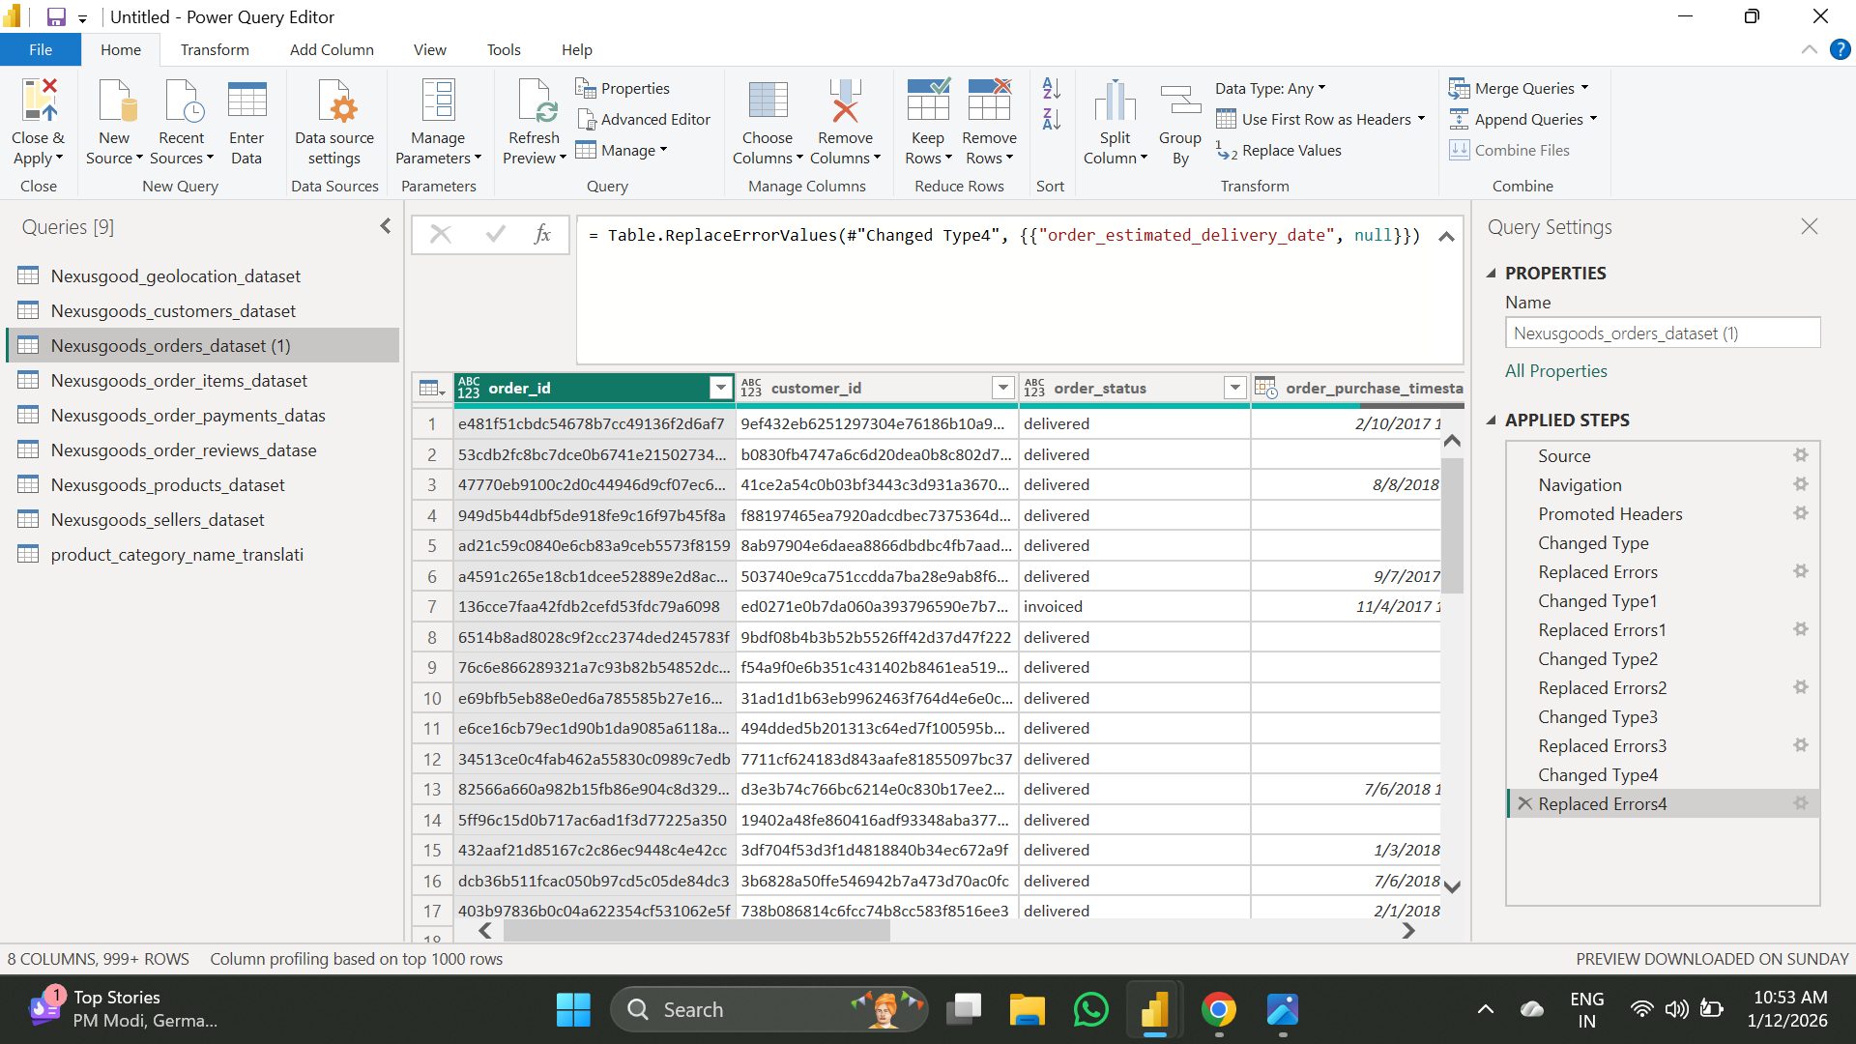

- Change the type of all the Dates of sheet 3 from any to Date/Time.
- Replace “Error” with “null”.

- Sheet 4/ Dataset 4 (Order items)
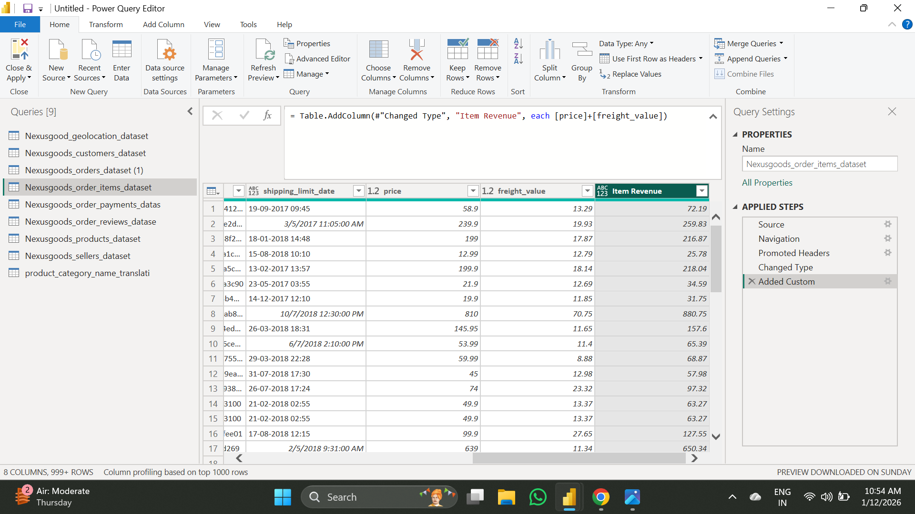
- Change Type of Price and Freight in “Decimal Number”.
- Add a column by adding price + freight, which gives us Revenue.

- Sheet 5/ Dataset 5 (Order Payment)
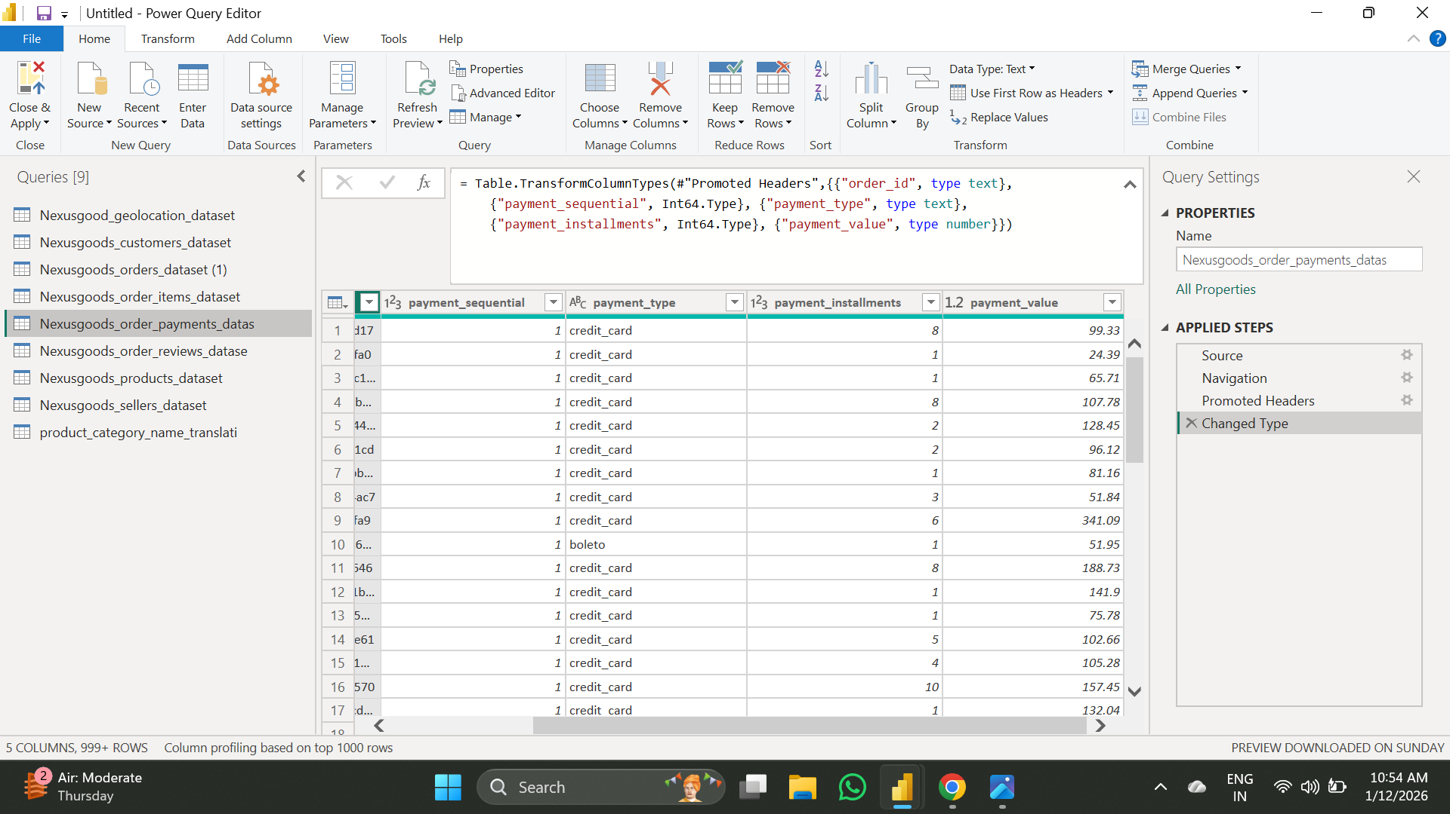
- Change Type of the type of payment in “decimal Number”.

- Sheet 6 / Dataset 6 (order review)
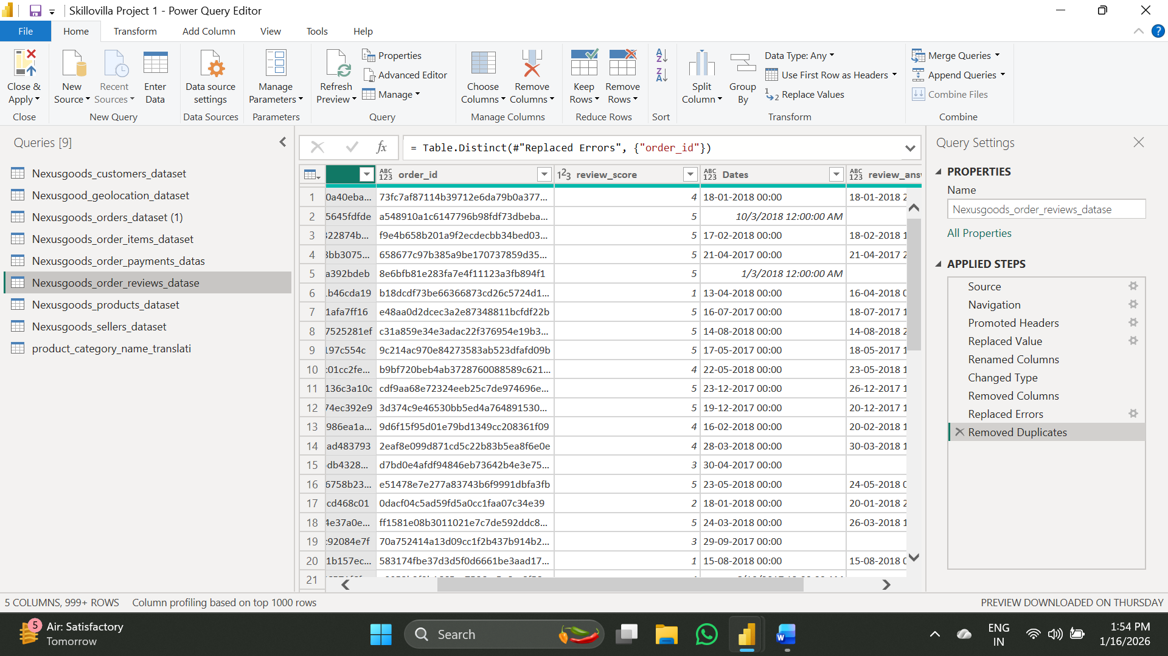
- Rename the review date to “Date”.
- Replace values from the column review_comment_message, “null” with “No Comment”.
- The Data type of “review_score” is changed to a whole number.
- From “review_score”, the “Error” is replaced by “null”.
- From Order_id, the duplicates are removed.

- Sheet 7/ Dataset 7 (Product)
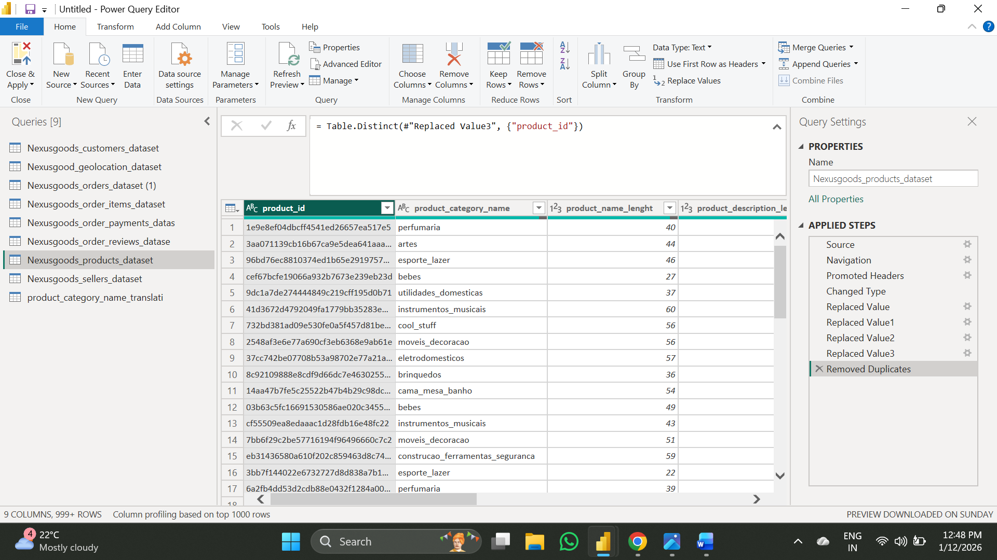
- Replace Values, the “null” values with the median of each column (Product_weight, Product_length, Product_height, Product_width)
- Remove Duplicate from the Product_id.
- Sheet 8/ Dataset 8 (Sellers)
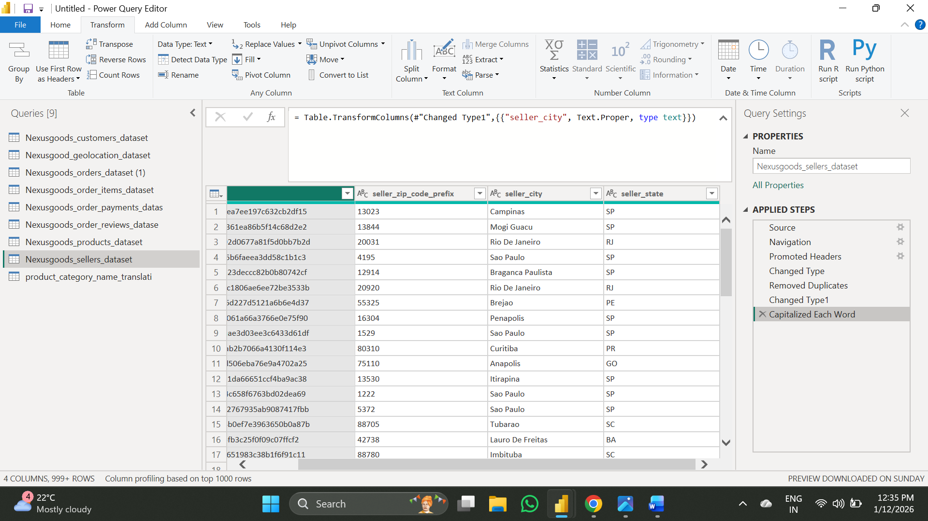
- Remove the duplicate from the seller_id.
- Change the type of Zip-Code into “Text”.
- Capitalizing the City Name.

- Sheet 9/ Dataset 9 (Product_Category_Translation)
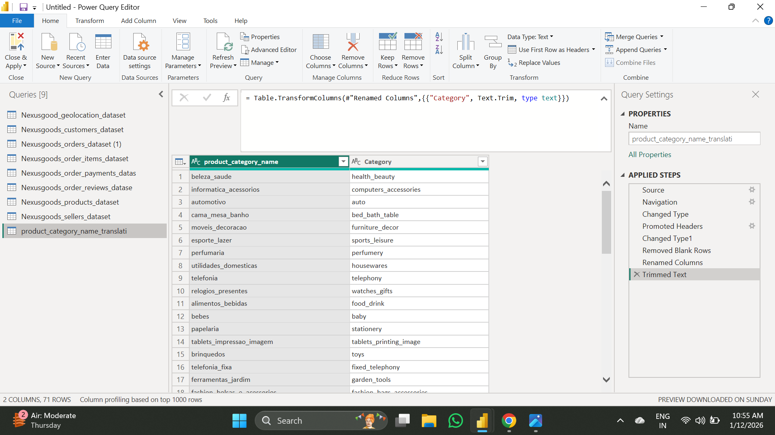
- Giving names to the columns by using the 1st line as a header.
- Rename the Column product_category_name_english into Category.
- Trim the Category column.

Data Modelling (Model View):
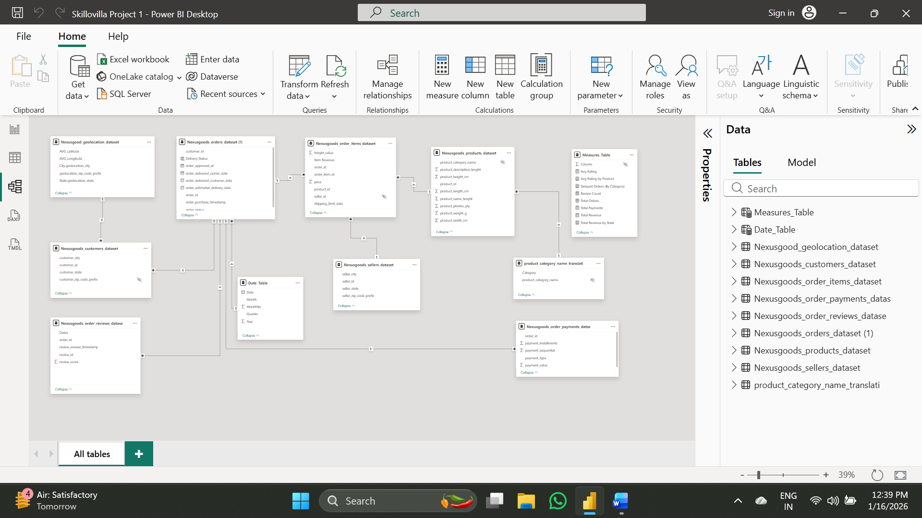
- The “Cardinality” will be “one-to-many” for every table, and the direction will be “Single”.
- The connections of every table with each other and with which columns are:
Table 1 | Table 2 | Columns
Nexusgoods_orders_dataset (1) | Nexeusgoods_customer_dataset | customer_id
Nexusgoods_orders_dataset (1) | Nexeusgoods_order_review_dataset | Order_id
Nexusgoods_orders_dataset (1) | Date_Table [Newly created table] | Order_purchase_timestamp
Nexusgoods_orders_dataset (1) | Nexeusgoods_order_payments_dataset | Order_id
Nexusgoods_orders_dataset (1) | Nexeusgoods_order_items_dataset | Order_id
Nexeusgoods_order_items_dataset | Nexeusgoods_products_dataset | Product_id
Nexeusgoods_order_items_dataset | Nexeusgoods_sellers_dataset | Seller_id
Nexeusgoods_products_dataset | Product_category_name_translation | Product_category_name
Nexeusgoods_customer_dataset | Nexeusgoods_geolocation_dataset | Geolocation_zip_code_prefix

- A Date Table is created to get the following columns, which will help in making quarterly analysis and also for the monthly trend.
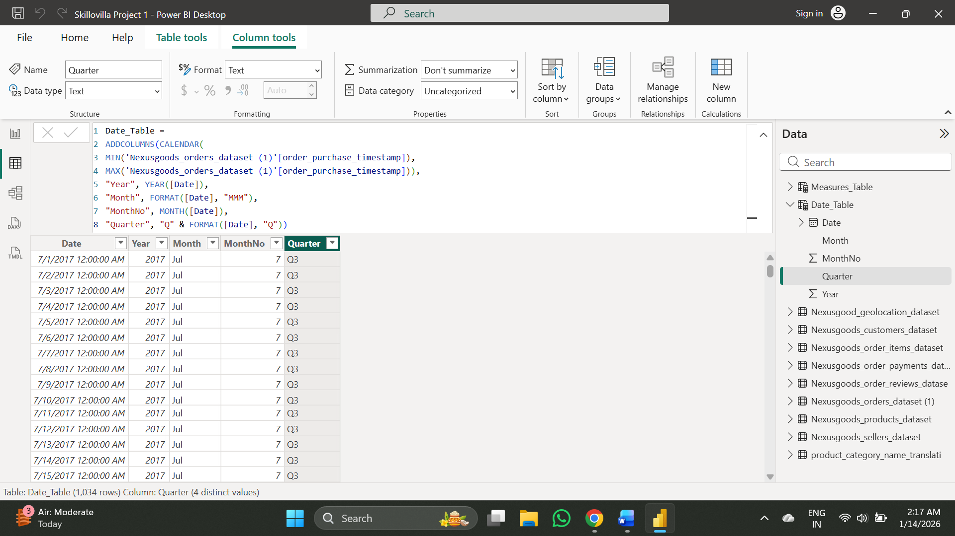

- The DAX Formula for creating a new table:
Date_Table =
ADDCOLUMNS(CALENDAR(
MIN('Nexusgoods_orders_dataset (1)'[order_purchase_timestamp]),
MAX('Nexusgoods_orders_dataset (1)'[order_purchase_timestamp])),
"Year", YEAR([Date]),
"Month", FORMAT([Date], "MMM"),
"MonthNo", MONTH([Date]),
"Quarter", "Q" & FORMAT([Date], "Q"))
- Columns which are created: Date, Month, MonthNo, Quarter, Year.
- Sorting the month column by MonthNo.

Measure Table Creation:
Avg Rating = AVERAGE(Nexusgoods_order_reviews_datase[review_score])
- Why to create: To get the total customer satisfaction level.

Delayed Orders (By Category) =CALCULATE(DISTINCTCOUNT('Nexusgoods_orders_dataset (1)'[order_id]),'Nexusgoods_orders_dataset (1)'[Delivery Status] = "Delayed",CROSSFILTER('Nexusgoods_orders_dataset (1)'[order_id], Nexusgoods_order_items_dataset[order_id],BOTH ))
- Why to create: Which product category have highest number of delayed orders.

Total Orders = DISTINCTCOUNT('Nexusgoods_orders_dataset (1)'[order_id])
- Why to create: To get the total number of specific orders.

Total Revenue = SUM(Nexusgoods_order_items_dataset[price]) + SUM(Nexusgoods_order_items_dataset[freight_value])
- Why to create: To get the total revenue generated by the orders.

Avg Rating by Product =
CALCULATE(AVERAGE(Nexusgoods_order_reviews_datase[review_score]),TREATAS(VALUES(Nexusgoods_order_items_dataset[order_id]),Nexusgoods_order_reviews_datase[order_id]))
- Why to calculate: To get the Top 10 and Bottom 10 products based on customer reviews

Total Payments =
COUNT(Nexusgoods_order_payments_datas[order_id])
- Why to create: To calculate unique orders that were paid, grouped by payment method.

Total Revenue by State = CALCULATE(SUM(Nexusgoods_order_items_dataset[price]) +SUM(Nexusgoods_order_items_dataset[freight_value]),CROSSFILTER(Nexusgoods_customers_dataset[customer_id],'Nexusgoods_orders_dataset (1)'[customer_id],BOTH))
- Why to create: To identify the state with high and low sales.

- The Measures table is not connected to any table, as it is not needed.
- A new Column is created, “Delivery Status” in Nexusgoods_orders_dataset.
Delivery Status =
If ('Nexusgoods_orders_dataset (1)'[order_delivered_customer_date]
> 'Nexusgoods_orders_dataset (1)'[order_estimated_delivery_date],"Delayed","On-Time")
- Some of the columns that are also hidden from the report view are
Customer_zip_code_prefix, Seller_id, product_category_name, Measure Table (column).

